Pentagonal Orthobicupola

Definition
# Source: AI Source: Provided by: [Data Path: Persons Table -> ID Column: 1, Name_En Column: Motasem Essam] -> From: [ChatGPT] on [7/25/2026]
A Pentagonal Orthobicupola is a convex polyhedron formed by joining two identical pentagonal cupolas at their decagonal bases, with both cupolas arranged in the same orientation.
It consists of:
- Two opposite regular pentagonal faces.
- Ten equilateral triangular faces.
- Ten square faces.
- Two pentagonal cupolas joined at their larger decagonal bases.
The two decagonal bases are joined internally and are not counted as external faces.
The Pentagonal Orthobicupola is the 30th Johnson solid (J30).

Geometric Structure
# Source: AI Source: Provided by: [Data Path: Persons Table -> ID Column: 1, Name_En Column: Motasem Essam] -> From: [ChatGPT] on [7/25/2026]
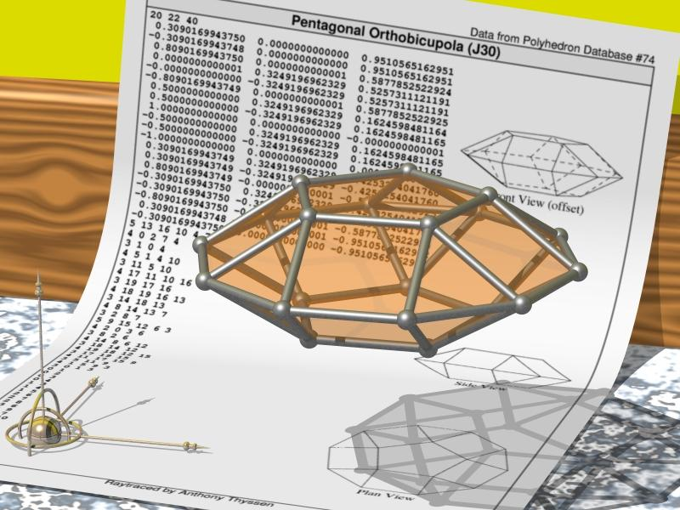
Its main elements are:
- Upper Pentagonal Face: The upper regular pentagonal face.
- Lower Pentagonal Face: The lower regular pentagonal face.
- Upper Pentagonal Cupola: The upper component of the solid.
- Lower Pentagonal Cupola: The lower component of the solid.
- Triangular Faces: Ten external equilateral triangular faces, five from each cupola.
- Square Faces: Ten external square faces, five from each cupola.
- Central Joining Region: The internal decagonal region connecting the two cupolas.
- Vertices: Twenty vertices where the edges meet.
- Edges: Forty edges forming the boundaries of the faces.
- Height: The perpendicular distance between the two opposite pentagonal faces.

Face Composition
# Source: AI Source: Provided by: [Data Path: Persons Table -> ID Column: 1, Name_En Column: Motasem Essam] -> From: [ChatGPT] on [7/25/2026]
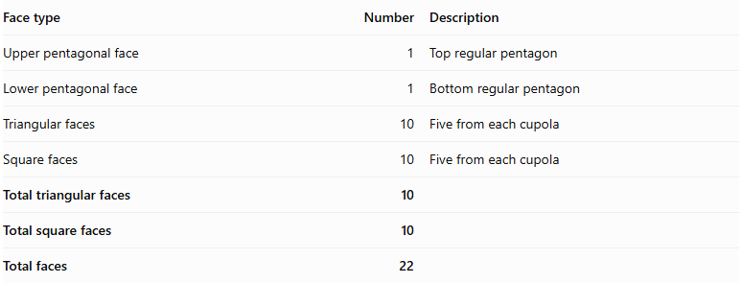
Face type | Number | Description
Upper pentagonal face | 1 | Top regular pentagon
Lower pentagonal face | 1 | Bottom regular pentagon
Triangular faces | 10 | Five from each cupola
Square faces | 10 | Five from each cupola
Total triangular faces | 10
Total square faces | 10
Total faces | 22
The two decagonal bases are joined internally and do not appear on the external surface.

Mathematical Properties
# Source: AI Source: Provided by: [Data Path: Persons Table -> ID Column: 1, Name_En Column: Motasem Essam] -> From: [ChatGPT] on [7/25/2026]
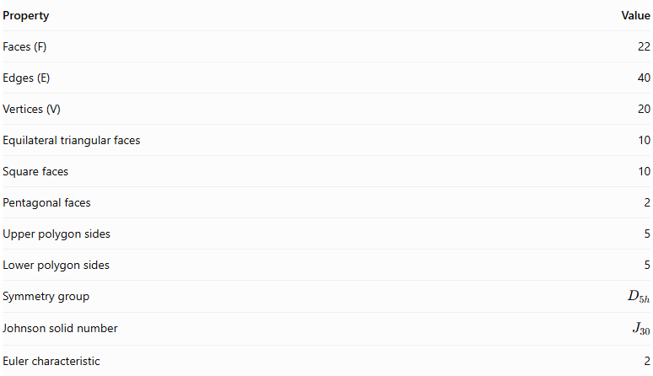
Property | Value
Faces (F) | 22
Edges (E) | 40
Vertices (V) | 20
Equilateral triangular faces | 10
Square faces | 10
Pentagonal faces | 2
Upper polygon sides | 5
Lower polygon sides | 5
Symmetry group | $$D_{5h}$$
Johnson solid number | $$J_{30}$$
Euler characteristic | 2
Euler's Formula:
$$V-E+F=2$$
$$20-40+22=2$$

Vertex Configuration
# Source: AI Source: Provided by: [Data Path: Persons Table -> ID Column: 1, Name_En Column: Motasem Essam] -> From: [ChatGPT] on [7/25/2026]
The Pentagonal Orthobicupola has two vertex configurations:
- 10 vertices: $3.3.4.4$
- 10 vertices: $3.4.5.4$
Here, 3 represents a triangular face, 4 represents a square face, and 5 represents a pentagonal face. The notation describes the faces surrounding each vertex in cyclic order.

Surface Area
# Source: AI Source: Provided by: [Data Path: Persons Table -> ID Column: 1, Name_En Column: Motasem Essam] -> From: [ChatGPT] on [7/25/2026]
For an edge length $a$, the surface area is:
$$\boxed{S=a^{2}(10+\sqrt{\frac{5}{2}(10+\sqrt{5}+\sqrt{75+30\sqrt{5}})})}$$
For a unit edge length:
$$S≈17.7711$$

Volume
# Source: AI Source: Provided by: [Data Path: Persons Table -> ID Column: 1, Name_En Column: Motasem Essam] -> From: [ChatGPT] on [7/25/2026]
For a regular Pentagonal Orthobicupola:
$$\boxed{V=\frac{5+4\sqrt{5}}{3}a^{3}}$$
For a unit edge length:
$$V≈4.6480$$
These formulas apply to the regular Johnson-solid construction.

Geometric Characteristics
# Source: AI Source: Provided by: [Data Path: Persons Table -> ID Column: 1, Name_En Column: Motasem Essam] -> From: [ChatGPT] on [7/25/2026]
- It is constructed from two identical pentagonal cupolas.
- The two cupolas are joined at their decagonal bases.
- Their orientations are aligned.
- It has two opposite regular pentagonal faces.
- It contains ten equilateral triangular faces.
- It contains ten square faces.
- It has 22 external faces.
- It has 40 edges.
- It has 20 vertices.
- It is a convex polyhedron.
- It has dihedral symmetry $D_{5h}$.
- It has two different vertex configurations.

Construction of a Pentagonal Orthobicupola

Geometric Instruments Used
# Source: AI Source: Provided by: [Data Path: Persons Table -> ID Column: 1, Name_En Column: Motasem Essam] -> From: [ChatGPT] on [7/25/2026]
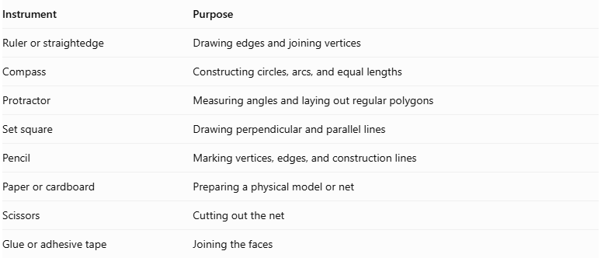
Instrument | Purpose
Ruler or straightedge | Drawing edges and joining vertices
Compass | Constructing circles, arcs, and equal lengths
Protractor | Measuring angles and laying out regular polygons
Set square | Drawing perpendicular and parallel lines
Pencil | Marking vertices, edges, and construction lines
Paper or cardboard | Preparing a physical model or net
Scissors | Cutting out the net
Glue or adhesive tape | Joining the faces

Instrument-Based Construction Procedures

Construct the Two Pentagonal Cupolas
# Source: AI Source: Provided by: [Data Path: Persons Table -> ID Column: 1, Name_En Column: Motasem Essam] -> From: [ChatGPT] on [7/25/2026]
- Draw two congruent regular decagons using a compass, ruler, and protractor.
- Construct a regular pentagon above each decagon, following the standard pentagonal cupola arrangement.
- Around each decagon, construct ten alternating lateral faces:
- Five equilateral triangular faces.
- Five square faces.
- Arrange the upper pentagon and lateral faces so that each cupola has the correct face adjacency.
- Repeat with matching dimensions for the second cupola.

Join the Cupolas
# Source: AI Source: Provided by: [Data Path: Persons Table -> ID Column: 1, Name_En Column: Motasem Essam] -> From: [ChatGPT] on [7/25/2026]
- Place the two decagonal bases opposite one another.
- Align their corresponding decagonal vertices and edges.
- Join the cupolas without introducing the 36° relative rotation used for the gyrobicupola.
- Match the square lateral faces of one cupola with the square lateral faces of the other along the joining region.
- Treat the joined decagonal bases as internal faces; they must not appear on the exterior.
- Check that all exterior faces meet edge-to-edge without gaps or unintended overlaps.

Complete the Solid Drawing
# Source: AI Source: Provided by: [Data Path: Persons Table -> ID Column: 1, Name_En Column: Motasem Essam] -> From: [ChatGPT] on [7/25/2026]
- Draw the two exposed pentagonal bases at opposite ends.
- Complete the ten triangular and ten square lateral faces.
- Use solid lines for visible edges.
- Use dashed lines for hidden edges when necessary.
- Verify the final face, edge, and vertex counts.
Construction restriction: This procedure uses geometric instruments and geometric relationships. It does not use coordinate-based construction.

Related Geometric Solids
# Source: AI Source: Provided by: [Data Path: Persons Table -> ID Column: 1, Name_En Column: Motasem Essam] -> From: [ChatGPT] on [7/25/2026]
- Pentagonal Cupola
- Pentagonal Gyrobicupola
- Triangular Orthobicupola
- Square Orthobicupola
- Pentagonal Orthocupolarotunda
- Pentagonal Orthobirotunda
- Elongated Pentagonal Orthobicupola
- Pentagonal Gyrocupolarotunda
Important distinction:
The Pentagonal Orthobicupola and Pentagonal Gyrobicupola have the same numbers and types of faces, edges, and vertices.
- Pentagonal Orthobicupola (J30): The two cupolas have aligned orientations.
- Pentagonal Gyrobicupola (J31): One cupola is rotated ${36}^{∘}$ relative to the other.

Main Classification
# Source: AI Source: Provided by: [Data Path: Persons Table -> ID Column: 1, Name_En Column: Motasem Essam] -> From: [ChatGPT] on [7/25/2026]
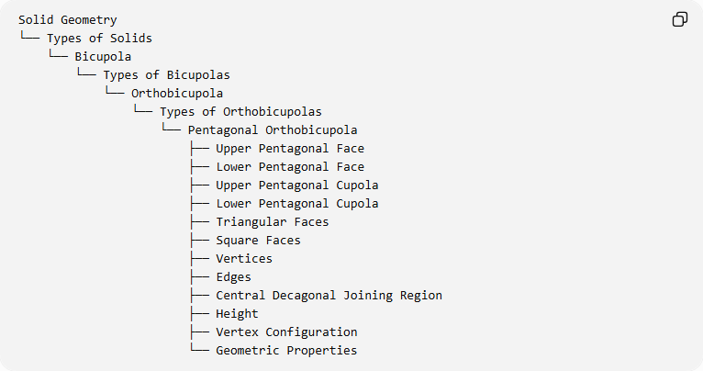
Solid Geometry
└── Types of Solids
└── Bicupola
└── Types of Bicupolas
└── Orthobicupola
└── Types of Orthobicupolas
└── Pentagonal Orthobicupola
├── Upper Pentagonal Face
├── Lower Pentagonal Face
├── Upper Pentagonal Cupola
├── Lower Pentagonal Cupola
├── Triangular Faces
├── Square Faces
├── Vertices
├── Edges
├── Central Decagonal Joining Region
├── Height
├── Vertex Configuration
└── Geometric Properties

Key Points
# Source: AI Source: Provided by: [Data Path: Persons Table -> ID Column: 1, Name_En Column: Motasem Essam] -> From: [ChatGPT] on [7/25/2026]
- The Pentagonal Orthobicupola is Johnson solid $J_{30}$.
- It is formed by joining two pentagonal cupolas at their decagonal bases.
- It has 10 equilateral triangular faces and 10 square faces.
- It has 2 regular pentagonal faces.
- It contains 22 faces, 40 edges, and 20 vertices.
- Its two cupolas have aligned orientations.
- Its symmetry group is $D_{5h}$.
- It is distinct from the Pentagonal Gyrobicupola (J31).

Conclusion
# Source: AI Source: Provided by: [Data Path: Persons Table -> ID Column: 1, Name_En Column: Motasem Essam] -> From: [ChatGPT] on [7/25/2026]
The Pentagonal Orthobicupola is a convex Johnson solid constructed by joining two identically oriented pentagonal cupolas at their decagonal bases. Its external structure consists of ten equilateral triangular faces, ten square faces, and two regular pentagonal faces, making it the 30th solid in the Johnson-solid classification.

